**WEBD-1000**

*Coding Challenge #5 CSS Zen Fields*

 Coding Challenges are to be completed and marked in class.

Code should be indented appropriately and semicolons always used. All other coding practices are up to the discretion of you instructor and will be covered in class. Coding Challenges must be completed in class (meaning: you must attend in order to have the dropbox opened for you).

Use [these starting files](https://www.google.com/url?q=https://drive.google.com/file/d/1Z1koee7H3yS5O3xUCO0b3neUkcTZ54S3/view?usp%3Dsharing&sa=D&ust=1574463962248000).

**Dynamic CSS Switching**

In Assignment 2 you created 2 separate CSS documents for one HTML5 page. You were advised to comment out the <link> elements you weren’t using at the time and when you needed to change the stylesheet, you were to comment accordingly.

Using your knowledge of Javascript and the DOM, in the supplied javascript starting file add code that will enable the functionality you saw on [CSSZenGarden](https://www.google.com/url?q=http://www.csszengarden.com/&sa=D&ust=1574463962249000).

Note: these screenshots are from a prior iteration of this challenge. Ignore “Style 3” ;-)

When “Style 1” is clicked:

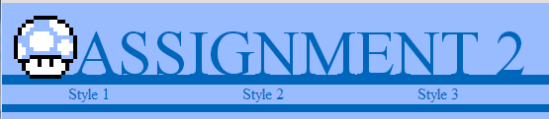

When “Style 2” is clicked:

